December 17, 2025

To Prospective Corporate Sponsors,

We are pleased to announce that the International Symposium on Remote Sensing 2026 (ISRS2026) will be held from May 13 to 15, 2026. The history of ISRS dates back to 1994, when the East Asia Committee for Space Environment Monitoring (EMSEA) initiated an international conference. Since 2012, ISRS has been co-organized annually by the remote sensing societies of Japan (RSSJ and JSPRS), China (CSPRS), and Korea (KSRS), and is now recognized as one of the major remote sensing symposia in East Asia.
ISRS2026 will be hosted by the Remote Sensing Society of Japan and the ISRS2026 Local Organizing Committee held at Kunibiki Messe in Matsue City, Shimane Prefecture. The symposium will also be jointly organized with the 80th RSSJ Annual Spring Conference. We sincerely appreciate your longstanding support, which has made this possible.
Accordingly, we would like to request your continued sponsorship for corporate exhibitions and contributions to the Student Paper Award Fund, in support of the objectives of ISRS2026.

Sincerely,
Dr. Tsuneo Matsunaga
Chair, ISRS2026
Local Organizing Committee

Sponsorship Details

1. Corporate Exhibition
- $1,500 (tax included) per booth
- Booth Setup: Desk W1800 × D450 mm; Panels W2400 × H2100 mm
Benefits:
- Company logo displayed on the official website
- 5–10 minutes corporate PR time during lunch using the projector in the poster hall
- Two complimentary full-access registrations (including lunch and banquet)
* For organizations with three or more participants, those beyond the two complimentary registrations should apply through the general registration process.
2. Student Paper Award Sponsorship
- $ 300 USD (tax included) per unit
Benefit:
- Company name announced at the Student Award Ceremony
3. Application & Payment Procedure
Please complete the application form and submit it via email (isrs2026@rssj.or.jp).
URL: https://www.rssj.or.jp/isrs2026/exhibitors.html
After submission, an invoice will be sent by email. Payment should be made by bank transfer (transfer fee borne by the applicant). Please contact the coordinator if you need details about the payment.
4. Application Deadline
April 17 2026 (Friday)
5. Contact Information
ISRS2026 Corporate Exhibition Coordinator (Fumitaka Ogushi)
Email: isrs2026@rssj.co.jp
HP：https://www.rssj.or.jp/isrs2026/exhibitors.html

Application Form for Exhibit Space and Student Paper Award Sponsorship
International Symposium on Remote Sensing (ISRS) 2026
13-15 May 2026, Kunibiki Messe, Matsue City, Shimane, Japan

To book your booth and/or student paper award, please complete this form and email it to isrs2026@rssj.or.jp.

Contact Information
Company Name：

Address：

Contact Name and Title：

Telephone： | E-mail：

Booth Space
Number of Booths |  |  | $2,000 USD/Booth  Desk: W1800×D450 mm,  Panel：W2400×H2100 mm
Exhibitors’ Information (Free pass)
If participants using a free pass have not yet been determined at the time of the registration, please inform us the information below by April 30 at isrs2026@rssj.or.jp.
No. | Name | Department | E-mail | Telephone
1
2
Attached file: company's logo file (.ai or .png)
Deadline: April 17 2026

Student Paper Award
Number of Student Paper Award |  | $300 USD/paper  The name of the sponsoring company will be formally acknowledged at the Student Award Ceremony.
Deadline: April 17 2026

I, the duly authorized representative of the above-mentioned organization, subscribe to exhibit space and/or student paper award at the ISRS2026.
Print Name:

Signature: | Date:

Exhibition hall in Kunibiki Messe

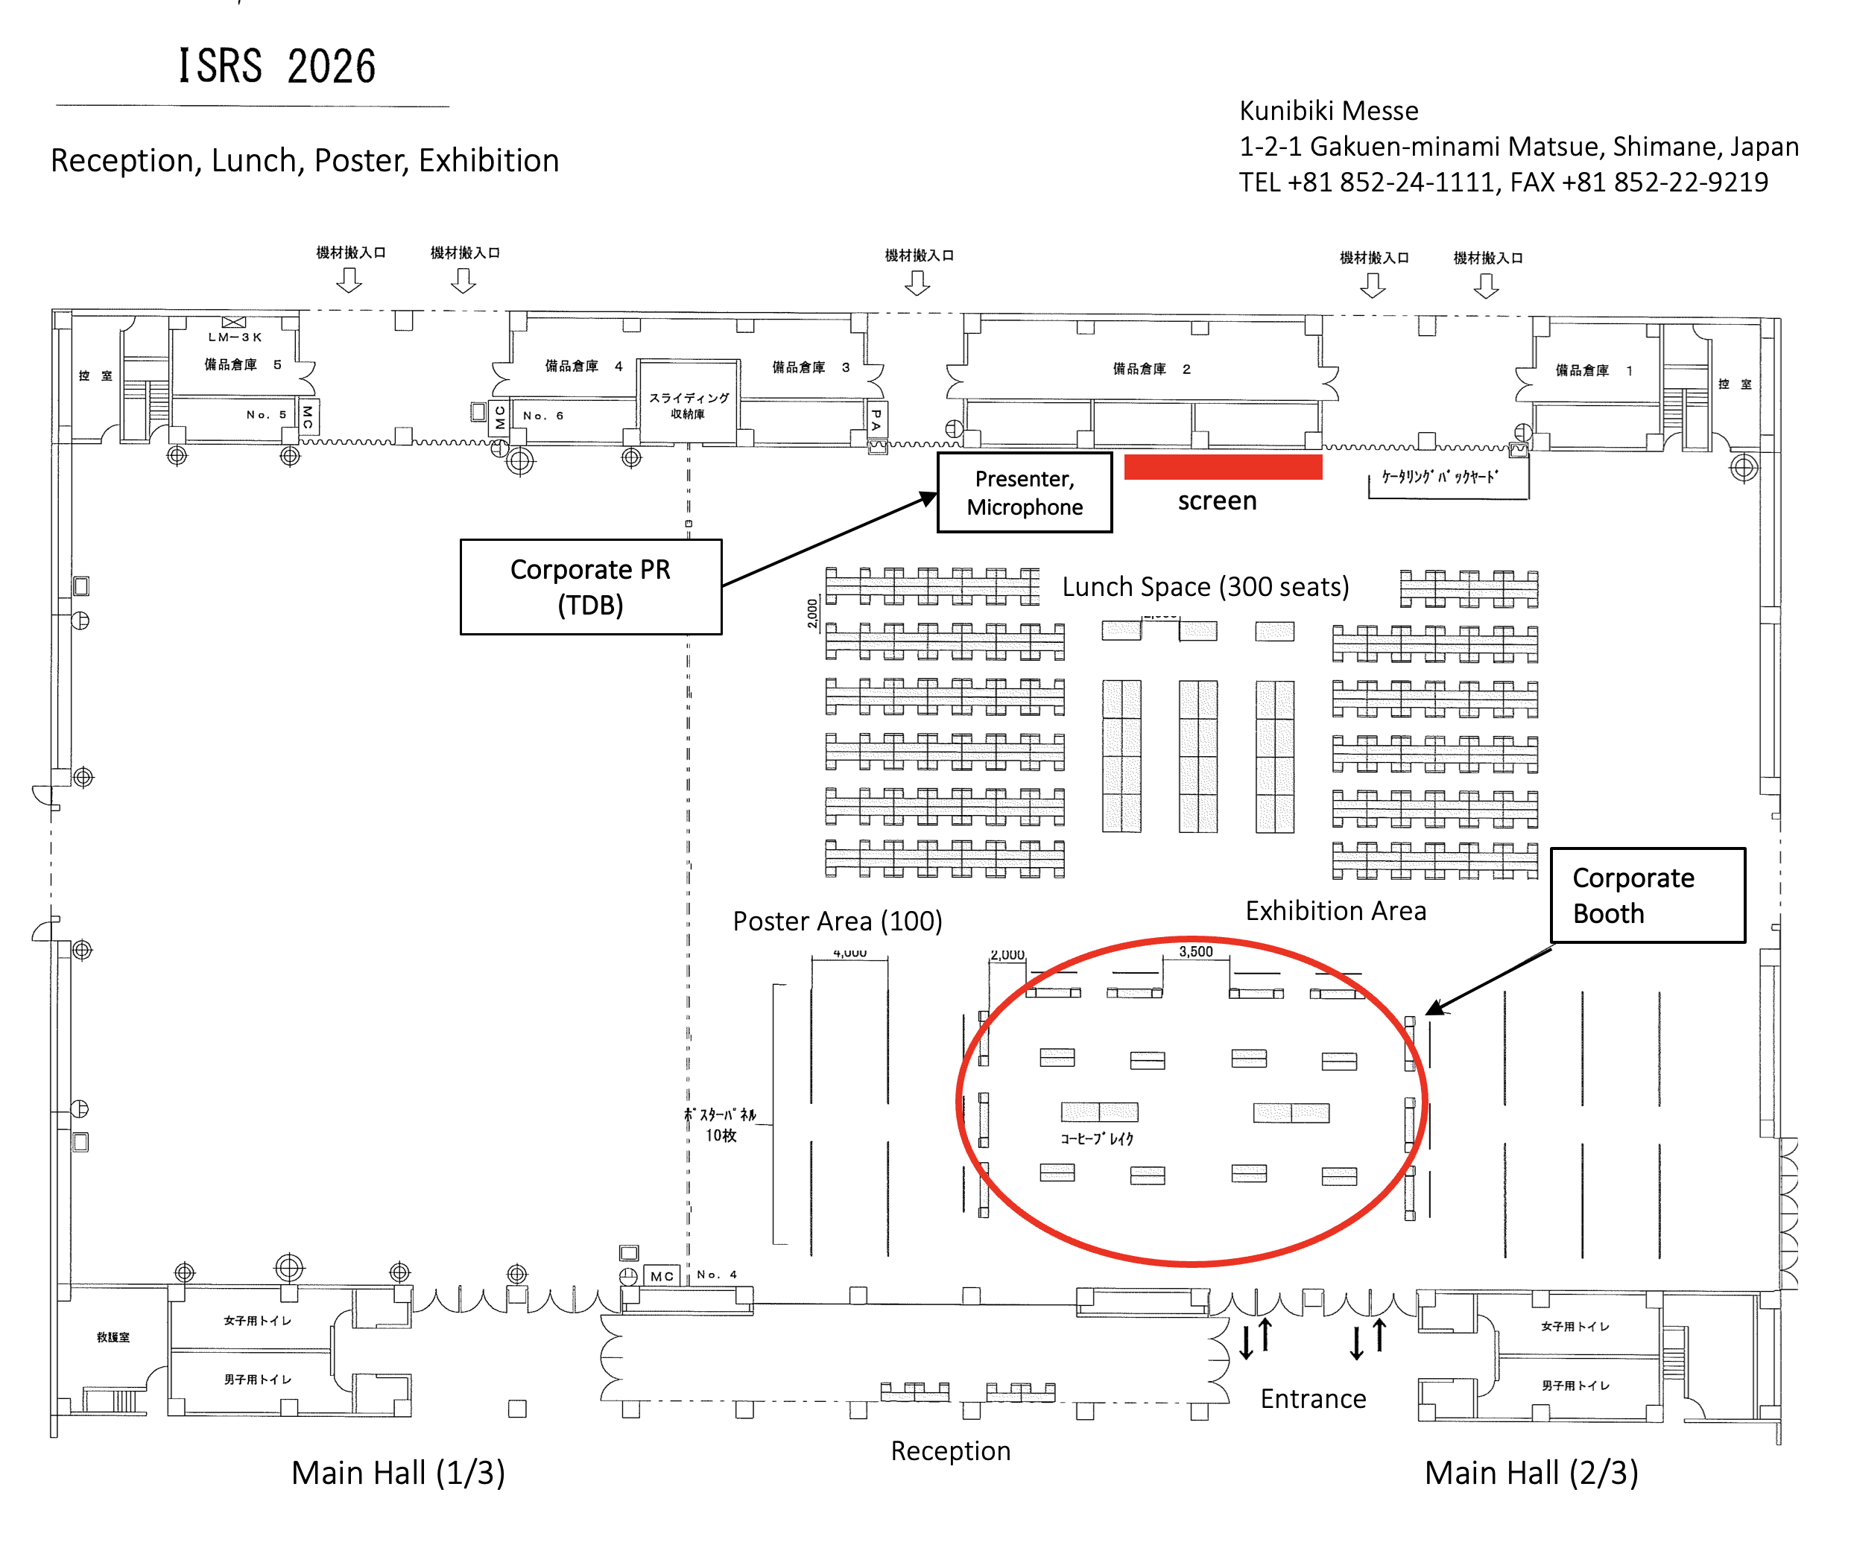
Access to Kunibiki Messe: https://www.kunibikimesse.jp/en/78

